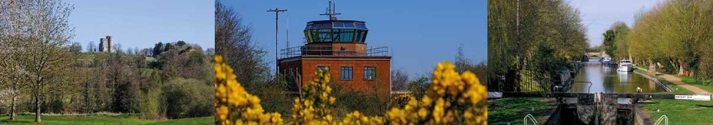

# Council Report for September 2023

### Written by your local Conservative team to keep you up to date.

### Cllr Paul Dick, Chieveley and Cold Ash Ward

## West Berkshire Council

#### Council

There was no meeting of Council this month.

The next meeting is on 5 October.

#### Executive

Executive met on 21 September to discuss:

* Capital Financing Report Financial Year 2023/24 Quarter One (EX4361)
* 2023/24 Revenue Financial Performance Quarter One (EX4360)
* Corporate Transformation Programme 2023-25 (EX4448)
* Results of Public Consultation - Potential Sports Pitch at Manor Park (EX4434)

Papers and a recording of the meeting can be found [here](https://decisionmaking.westberks.gov.uk/ieListMeetings.aspx?CId=117&Year=0).

The next meeting is on 2 November.

#### Transport and Highways

##### Major works on Aldermaston Wharf Lifting Bridge

WBC will be starting major refurbishment works on Aldermaston Wharf Lifting Bridge, from 8 January to 15 March 2024, to ensure the bridge continues to function reliably and effectively for many years to come.

The canal will be closed from 8-14 January 2024 to allow the removal of the bascule and then again, from 26 February-15 March 2024 to allow the bascule to be reinstalled. The removal of the bascule section of the bridge will also cause the closure of the A340 from 8 January 2024 until it is reinstalled and made operational again on 15 March 2024.

Alternative routes have been identified and will be clearly signposted to facilitate the movement of vehicles and pedestrians during the closure period.

#### Public Protection

##### Public Protection Partnership Animal Warden Team awarded RSPCA PawPrints award

WBC was one of 73 local authorities and public sector organisations across England and Wales have been recognised by the RSPCA for pioneering animal welfare work. The Public Protection Partnership's Animal Warden team have been awarded a platinum award for their work with stray dogs.

Running since 2008, the RSPCA’s flagship PawPrints awards recognises local authorities and public bodies for going above and beyond to deliver world-class animal welfare services. These can include anything from initiatives to see more stray dogs safely into kennels, schemes to safeguard pets whose owners have been taken into care and housing policies that allow tenants to share their home with their pets.

The Public Protection Partnership's Animal Warden team, alongside the other awardees will be recognised at a special ceremony in Leeds in November this year.

#### Business and Economy

##### Young Traders at Newbury Market

Newbury Market is offering a free pitch for young traders aged between 16-30!

Young residents can test out their idea in a friendly environment gaining invaluable customer feedback and a great market research opportunity!

For more information on how to apply contact Caroline on 07399 122964 or email: [towncouncil@newbury.gov.uk](mailto:towncouncil@newbury.gov.uk).

##### Prince's Trust Support for young people

Residents between 18-30 years old and looking to start their own business could be helped in their venture by the Prince’s Trust programme.

Prince’s Trust is a charity that helps young people develop confidence, find work and start their own business! They have dedicated mentors that guide you through a business plan as well as help you test out your idea for the market!

If this sounds like something you’re interested in, check out the website and book yourself onto an information session: <https://www.princes-trust.org.uk/how-we-can-help/support-starting-business>

##### Berkshire Growth Hub Courses

The Berkshire Growth Hub is still offering business support including: Start Up Courses, High Grow Course and Masterclasses. For more information, please visit their website: <https://berkshiregrowthhub.co.uk/>

#### Children and Young People

##### Schools to open as usual as checks find no crumbly concrete

Schools across West Berkshire have been opening as usual with none of the problematic crumbly concrete (RAAC) having been identified locally.

WBC have been following Department for Education guidance and had already completed a visual inspection of all schools that fall within this guidance. This has not found any indication of the use of RAAC in any of the school buildings they are responsible for and as such all schools are safe to open as usual this month.

In addition to the visual inspections, and with safety as the utmost priority, WBC will be undertaking some further, more intrusive, work at a number of schools in the district (for example, where access has been difficult). Although this is being done as a precautionary measure WBC have plans in place in the unlikely event that this material is found to be present.

##### 'The Big Ambition' survey

WBC’s Youth Council is supporting the Children’s Commissioner's Big Ambition survey and would like to help capture the voices of children from across West Berkshire.

‘The Big Ambition’ survey is designed to hear directly from children, young people, and parents from across the country, from all backgrounds to make sure their needs are addressed. The survey is for all children and young people aged 6 to 18 and wants to hear about their schools, communities, family life, and the wider world. Alongside this, parents and other adults can complete the survey on behalf of children aged 0 to 5, to ensure they also hear from early years settings.

There is an easy read version of the survey and different questions based on the age of the participant. 'The Big Ambition' [webpage](https://www.childrenscommissioner.gov.uk/the-big-ambition/) also includes resources and overviews of the survey.

##### Badgers Hill learners start term in brand new building

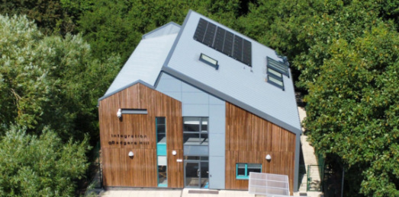Learners at the Badgers Hill Integration facility in Calcot started this term in their brand new purpose built building. The £2.2 million project, funded by West Berkshire Council has seen Badgers Hill completely rebuilt as part of the alternative provision for young people unable to access mainstream education.

Integration @ Badgers Hill is one of six special units run by iCollege in West Berkshire supporting young people in alternative settings to achieve their highest possible education outcomes, develop a strong positive attitude, develop self-confidence and prepare them for their chosen future.

#### Health and Wellbeing

##### Flu Vaccine

The groups below are now eligible for a flu vaccine:

* those aged 65 years and over
* those aged 6 months to under 65 years in clinical risk groups
* pregnant women
* all children aged 2 or 3 years on 31 August 2023
* primary school aged children (from Reception to Year 6)
* those in long-stay residential care homes
* carers in receipt of carer’s allowance, or those who are the main carer of an elderly or disabled person
* close contacts of immunocompromised individuals
* frontline workers in a social care setting without an employer led occupational health scheme

Residents can book or manage a free NHS flu vaccination at their local pharmacy.

#### Current Consultations

* [Francis Baily Primary School - School Streets Scheme Feedback Survey](https://www.westberks.gov.uk/FBschoolstreets)– closes 3 March 2024
* [Berkshire’s Local Nature Recovery Strategy](https://www.westberks.gov.uk/LNRS2023) – closes 31 December
* [Draft Rights of Way Improvement Plan (ROWIP) 2023-2033](https://www.westberks.gov.uk/draftrowip) – closes 23 November
* [Delivering Better Value in SEND Programme (DBV in SEND) Survey 2023](https://www.westberks.gov.uk/DBV2023) – closes 29 October
* [Draft Special Educational Needs and Disabilities (SEND) Strategy 2023-2028](https://www.westberks.gov.uk/draftsendstrategy) – closes 29 October
* [Childcare and Out of School Provision Parents Survey 2023](https://www.westberks.gov.uk/childcare2023) – closes 1 October

# Parish Matters

#### I have been pleased to contribute to various Council committees including Planning, Licencing and external bodies too. Within the ward, I am assisting a considerable number of residents with a range of issues. Officers are always quick to respond. I have also joined the local Community Speed Watch, and have been active on the roadside. I would encourage more residents to get involved.